Login to new CMS R18

Using Chrome : Go to the new web link https://jhgarlandcms:8443/CMSWeb/ ; click on “Advanced” to proceed.

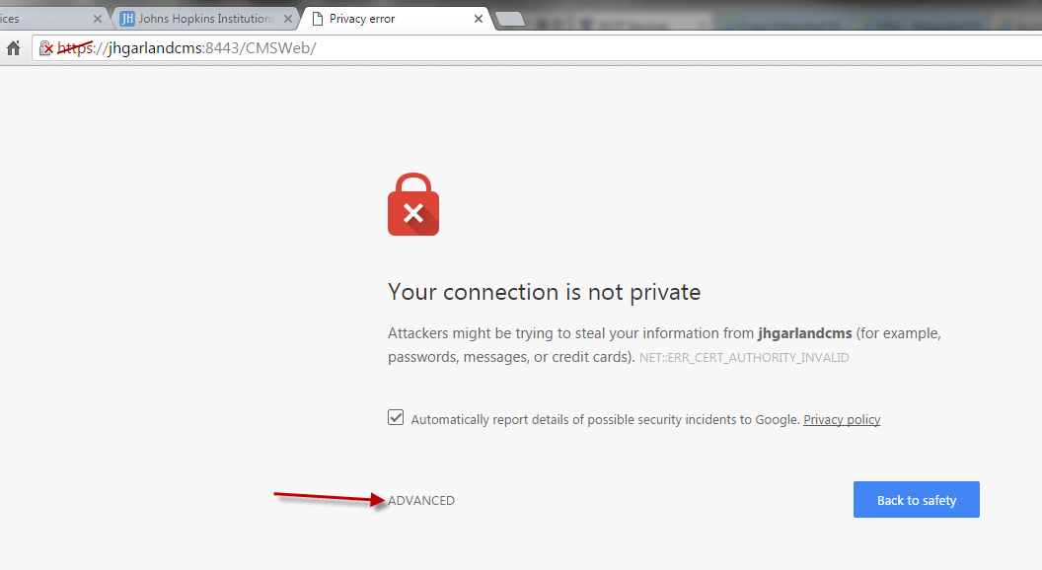

Then you will need to click on the “proceed” option provided on the next screen.

Using Internet Explorer : Go to the new web link https://jhgarlandcms:8443/CMSWeb/ ; click on the highlighted link to proceed.

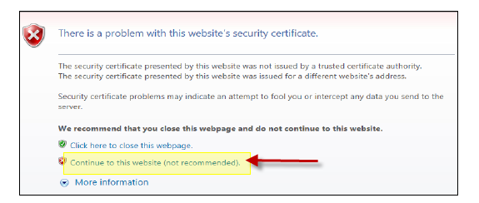

When prompted for your password you will need to use a DEFAULT password “avaya123” (all lower case letters). You will then be prompted to change the password of “avaya123” to a new password. That new password must meet the following parameters:

Passwords will need to consist of 6 or more characters, including one upper case and one lower case letter and at least one numeric character.

Passwords will be Denied if the new password….
- Is a rotated version of the old password
- is a change in case of the old password
- is similar to the old password (e.g. over half of the characters are the same)
- is a simple word
- is a palindrome
- is a repeat of the previous password(s)
- has too many consecutive characters
- contains the username in some form

